ATOMIC SLUSH

About us

THE DFW frozen beverage company! We’re looking to serve the DFW area with an experience like no other by providing a frozen beverage of your choice from our selection only using the freshest ingredients and finest products we can possibly offer. Our goal Is to stray away from the fake artificial flavors and dyes found in pre-mix bags and provide a service with restaurant quality drinks for our patrons. With a combined 15 years of service industry experience, my fiancé and I have curated a master list of cocktail recipes to choose from that best fits your wants for your perfect event. Whether it’s a birthday party, graduation, wedding, corporate event etc. our standards are set high and aim to provide a product and service you will not forget.

* If you could proof read this and make any changes to make it sound more professional or organic, id appreciate it. I don’t intend for this to be on the front page but maybe tucked away in the back of the website on a “about us” tab. I picture the front page being simple and straight to the point but with enough direction to answer any potential questions

**The “Machine”**

We offer a double-headed machine with each head carrying 9 Liters (20 Liters total!) of your two chosen flavors. Our machines will be delivered to your desired location as long as it is within reach of an outlet and directly out of the sun. This is to ensure that there isn’t any strain and overheating of the machine especially on hot summer days. The rental of the double headed machine, will provide two of our in-house made pre-mixes of your choice, 75 ct-9oz cups, delivery and setup. The total of frozen beverages served will roughly be about 65-75 9 oz. drinks. This is ideal for parties of 25-30 guest. Additional mixes may be purchases for larger parties

**Recipes**

This will also hopefully be apart from the homepage. A separate tab labeled “recipes”. I envision the recipe tab to be in a grid form with pictures of the cocktails/recipes that will be offered with each picture being a link to the recipe and the ingredients for the consumers knowledge.

* The recipes still need to be tweaked so I wouldn’t worry about the specifications for now. The layout and design can be worked on now and then the specs added later

**Frozen Classic Margarita**

Tequila 3L

Lime 1.5 L

Sugar 1.5 L

Orange Liqueur 1 L

Water 2 L

**_____________________________________________________________________________**

**Frozen Pina Colada**

Coconut Rum- 2.5L

Coconut Cream- 1.84L

Pineapple Juice- 1.63L

Lime Juice- 0.4 L

Water-2 L

Ticaloid powder- 33 G

**Coconut Cream**

24 Cups Coconut Milk

12 Cup Desiccated Coconut

28 Cups Turbinado Sugar

4 Cups Water

Instructions:

1. Bring coconut milk, water, sugar and desiccated coconut to a boil in saucepan. Simmer on Low/Medium Heat for 15 minutes, stirring consistently to assure all sugar is dissolved and not burning on to the bottom of pot

2. Remove from heat

3. Add mixture in increments to a blender and blend.

4. Strain mixture through fine sieve and press to extract all liquid

5. Repeat until all liquid has been used

6. Store, refrigerated, until use

_______________________________________________________________

**Frozen Strawberry Daiquiri**

Rum- 2.04 L

Strawberry Cordial- 2.04

Lime-0.69 L

Simple- 1.03 L

Water-2.30 L

|  |
| --- |
| Strawberry Cordial (Yield 4L)  70oz IQF Strawberries  42oz White Sugar  1.25L Water |

**_______________________________________________________________________________________________________**

**Frozen Paloma**

Tequila-1.62 L

Orange Liqueur- 0.54 L

Grapefruit- 2.55 L

Simple Syrup- 1.08 L

Lime- 1.08 L

Water- 2.16 L

**Whiskey Coke**

Whiskey- 3 L

Coke- 1 L

Lime- 1 L

Water- 5 L

Yield: 10 L

**Frozen Cosmo**

Vodka- 1.4 L

Orange liqueur- 1.4 L

Lime- 1 L

Lemon- Orange- .7 L

Simple- 1.4 L

Cranberry juice- 2.06 L

Water- 1.4 L

Yield: 10L

**Moscow Mule**

**Atomic Slush,** accepts no liability for damage or injury resulting from misuse of our equipment or product by customer, including movement of equipment or other alteration of equipment as installed by employees of Margarita Masters. The customer assumes complete and full financial responsibility for the equipment including liability for misuse and payment for repair in case the equipment is damaged through neglect or misuse.

**Atomic Slush** does not supply any liquor or alcohol beverages. Our mixes **DO NOT** contain liquor or alcohol. We would also like to remind you to Please, Drink Responsibly and always use a designated driver if you must travel !!

**Pricing**

As far as pricing goes, I don’t want any solid prices to go onto the website. A professional “request a quote” box will do just fine. Prices will vary depending on the time of year, holidays and demand. Examples below.

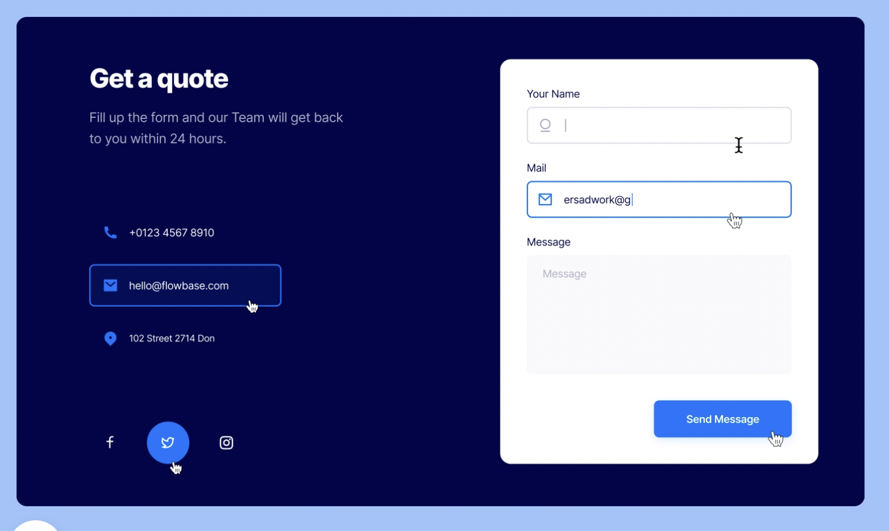

**Website examples:**

Just a couple examples here of some websites

